
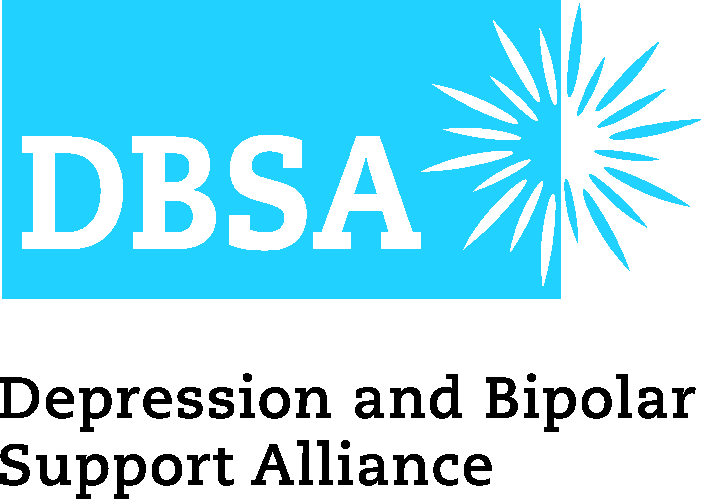
IBPF Contact: Debbie Smith
(858) 764-2496 dsmith@InternationalBipolarFoundation.org

DBSA Contact: Cindy Specht
(312) 988-1163
cspecht@DBSAlliance.org

## For Immediate Release ##

SAY IT FORWARD ANTI-STIGMA CAMPAIGN USES TRUTH TO BREAK THE chains of STIGMA
(San Diego, September 10, 2013) — When it comes to mental health conditions, silence is not golden. Silence breeds stigma, and stigma hurts: it prevents people from seeking life-saving treatment and support. That’s why the International Bipolar Foundation (IBPF) and the Depression and Bipolar Support Alliance (DBSA) have joined forces to promote Say It Forward 2013, an email and social media anti-stigma campaign that educates people about the reality of mental health conditions.
“Although much progress has been made to change attitudes about mental health conditions, many still acknowledge discomfort towards people with mental illnesses,” explains Scott Suckow, Executive Director of the International Bipolar Foundation. “These perceptions lag behind those of other health conditions, such as diabetes and cancer. Through campaigns like Say it Forward, we can separate myth from fact and help those facing mental health issues feel comfortable seeking care and support.”
The World Health Organization reports that 1 in every 4 people, or 25% of individuals, develops one or more mental health disorders at some stage in life. Yet only 1 in 3 Americans gets treatment. Among individuals with bipolar disorder, 25–50% attempt suicide at least once, and suicide is a leading cause of death in this group. This is a preventable tragedy because with proper treatment, individuals with mental health conditions can—and do—achieve their dreams and lead full, rewarding lives.
Say It Forward, established by IBPF, reached more than 10,000 people last year. In 2013, Say It Forward has a goal of expanding its reach to 20,000 individuals. The campaign will begin September 30, and run up to and include International Bipolar Awareness Day, October 10, 2013.
DBSA President Allen Doederlein shares, “The work DBSA and IBF do to educate and support people living with mood disorders is important and impactful—but it’s only the beginning. The Say It Forward 2013 campaign provides a vital next step, with a user-friendly and simple way to connect with a much broader audience, made up of people who may or may not have mental health concerns themselves. All of us, across the globe, need to be reminded that these conditions are serious and life-threatening, but also highly treatable. The first step to wellness is speaking up, and that’s what Say It Forward is all about!”
Truth has the power to affect change. IBPF and DBSA invite all to join us by taking a simple step—visit SayItForwardCampaign.org beginning September 30th through October 10th, and share the myths and facts of mental illness by email, Facebook, and/or Twitter.
##

The International Bipolar Foundation (IBPF) is a non-profit organization headquartered in San Diego, with globally accessible programs in over 75 countries. The organization’s focus is on eliminating bipolar disorder for the nearly 30 million or 2.4 % affected worldwide through the advancement of research, improving the quality of care and support and to erase the associated stigma through public education and advocacy. Services support consumers, caregivers and professionals and are offered free-of-charge. IBPF’s signature programs include Webinar and Lecture Series, Healthy Living with Bipolar Disorder book, Outreach and Referral database and the Mental Health Awareness Patch for the Girl Scouts of the Unites States of America.

For more information, please visit www.InternationalBipolarFoundation.org or call (858) 764-2496.

The Depression and Bipolar Support Alliance (DBSA) is the leading peer-directed national organization focusing on the two most prevalent mental health conditions, depression and bipolar disorder, which affect more than 21 million Americans, account for 90% of the nation’s suicides every year, and cost $23 billion in lost workdays and other workplace losses. DBSA’s peer-based, wellness-oriented, and empowering services and resources are available when people need them, where they need them, and how they need to receive them—online 24/7, in local support groups, in audio and video casts, or in printed materials distributed by DBSA, our chapters, and mental health care facilities across America. Through more than 700 support groups and nearly 300 chapters, DBSA reaches millions of people each year with in-person and online peer support; current, readily understandable information about depression and bipolar disorder; and empowering tools focused on an integrated approach to wellness.
For more information, please visit www.DBSAlliance.org or call (800) 826-3632.

